ComS 319 Homework #2 Report

**Approach:**

**Validation1.html –** I first set the title to “Validation Form” and made sure it was linked to my JS project. Then in the body I included a filed set that holds all of my inputs. Each line on the page consists of a label, an input (Text, drop down), and a hidden image. If the image passes the constraints (in the js) then it will unhide the images next to the input boxes. Lastly the continue box runs the validation function

**Validation1.js – Each** function will be explained individually

Valid1 – Checks whether valid return true and if it does then it will open validation2 in a second.

Valid – This runs checker functions to tell wether all inputs are correct and if they are it will move on to next page

Empty, isLetter - both use radix to determine if the input it correct (empty is just “!str==””)

Correct, incorrect – Takes in names of img locations and sets hidden to false to show the corresponding image

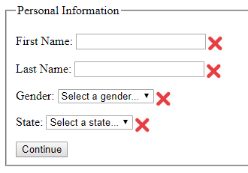**Below is what you would see at first If you clicked Continue right away**

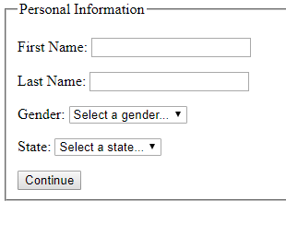

**Some extra test cases to show –** Names can only be alphanumeric and cannot contain symbols , and gender and state need to be selected

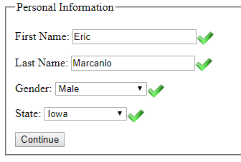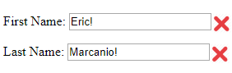

**When a User gets something incorrect an alert will also display telling them what they need to fix-** This was done by having each incorrect If statement add to a string that would be the alert message. If any of the errors are fixed it will be removed from the alert message.

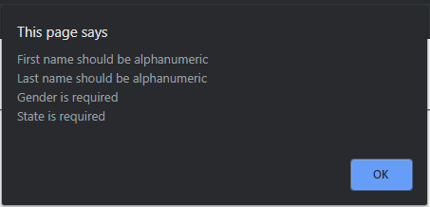

This is what would display if nothing was inputted

**Approach:**

The second page is the exact same approach to the first just different things are being checked

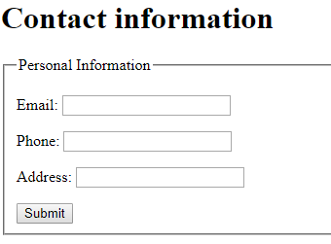This is the box seen at first

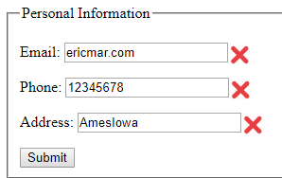This is showing an incorrect result

Email does not have an @

Phone number is not 10 numbers

Address does not contain a comma

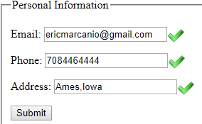This now shows the correct version

Also the phone number with the dashes as well

 no special chars are allowed for email

10 chars but one is a letter

If the user ever gets something incorrect it will alert them what is incorrect. Same as last time if something is fixed then it will get removed from the alert message.

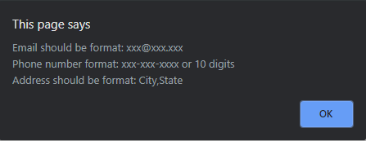

When all the information is correct and submit is selected an alert come to user

